**EMIF Group Links Infrastructure Model to Addressing Global SDG Financing Gap with Strategic Board Appointment**

**Toronto, Canada Feb 3, 2025—** “***Only 17% of Sustainable Development Goals (SDGs) targets currently on track***” was a key highlight focusing on critical challenges at the recent "2025 Dialogue on Public Finance and SDGs" at Columbia University. The Dialogue underscored the pressing need for innovative financing solutions to close the sustainable investment gap. This coincides with the official announcement of EMIF Group’s growing collaboration and partnership to proudly include the addition of Diana Smallridge, Founder and CEO of Momentus Global, to its Advisory Board.

John Safrance, CEO of EMIF Group, stated, "The inclusion of Diana in our Advisory Board aligns with our commitment to collaborate with leading experts and organizations dedicated to bridging the global financing gap for SDGs. Her expertise will be vital as we continue to innovate and drive investments that foster sustainable economic growth in underserved regions."

Diana Smallridge, as CEO and founder of Momentus Global, brings more than 25 years experience and a proven track record to facilitating financial structures that transform global development goals into actionable outcomes. She is one of the world’s leading experts in designing models to ensure global development initiatives can be resourced and realized.

“I want to make sure the world’s to-do list (the SDGs) can be financed."

Reflecting on her appointment, Diana Smallridge commented, " With close to one-third of the SDGs experiencing significant financing gaps and setbacks, it is time for serious innovation in development finance. EMIF knows how to make infrastructure projects bankable and accelerates progress to the SDGs. The drive and vision of the team is inspiring!”

The EMIF Group's Advisory Board, consisting of diverse experts like Nazmeera Moola, Chief Sustainability Officer at Ninety One, and Noel Dekking, Energy Transition Manager for Pluspetrol, warmly welcomes Ms. Smallridge. Their collective expertise will further enhance EMIF Group's ability to develop and catalyze global infrastructure projects, aiming to improve financial inclusion, mobilize private investment, and empower developing regions.

**About EMIF Group Inc.:** EMIF Group is committed to accelerating sustainable infrastructure development in developing regions by leveraging private capital and extensive development expertise. The organization focuses on making strategic investments that close the development gap and enhance community resilience.

**Key Partnership**: EMIF Group has formed a strategic partnership with UN Habitat through the Cities Investment Facility (CIF), aiming to tackle one of the most pressing challenges in emerging markets and developing economies (EMDEs): the scarcity of bankable and sustainable infrastructure projects. This collaboration leverages the strengths and networks of both organizations to scale up infrastructure development that is not only financially viable but also sustainable, supporting the broader agenda of advancing the 17 Sustainable Development Goals (SDGs).

**Media Contact:** [Jacqueline Way [jacqueline@emifgroup.com](mailto:jacqueline@emifgroup.com) +1 778 322 7703]

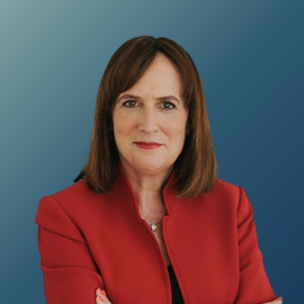Diana Smallridge

Founder and CEO, Momentus Global

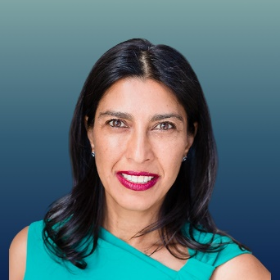

Nazmeera Moola

Chief Sustainability Officer, Ninety One

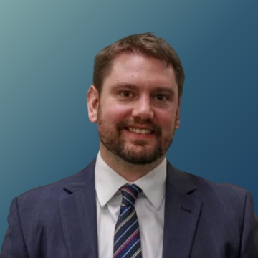

Noel Dekking

Energy Transition Manager, Pluspetrol



Christel Bourbon-Séclet

Director, City Finance Programme C40 Cities Climate Leadership